Department: | CSE(AI)
Programme: | BE- CSE(AI)
Course Code & Course Name | CSA0702 - Computer Networks
Academic Year / Batch | 2024
Faculty Name | Dr. R. Senthamil Selvan
Assignment Title | Design and Implementation of a VLAN-Based Enterprise LAN Using Cisco Packet Tracer
Date of Issue | 31 August 2026
Date of Submission | 1 September 2026
Maximum Marks | 100
Course Outcome(s) - CO | CO4: Design and configure switched/VLAN-based LANs and implement inter-VLAN routing to meet enterprise networking requirements.
Bloom's Taxonomy Level | L3 - Apply / L4 - Analyze
SDG Mapping (SDG 1-17) | SDG 9: Industry, Innovation and Infrastructure
Industry / Societal Relevance | VLAN segmentation is widely used in real enterprise, campus, and institutional networks to isolate departments, improve security, and manage broadcast traffic efficiently.
ASSIGNMENT

Problem Statement and Problem Formulation
The assignment involves designing and implementing a VLAN-based enterprise Local Area Network using Cisco Packet Tracer. The network consists of four departments: Administration, Faculty, Students, and Guests. Each department is placed in a separate VLAN to provide logical network segmentation. Appropriate IP addressing, switch port assignments, trunking, and inter-VLAN routing are configured to enable communication between different network segments.
Objective and Expected Outcomes
Objective
To design and implement a VLAN-based enterprise LAN that separates departmental networks while enabling successful inter-VLAN communication.
Expected Outcomes
- Four separate VLANs are created for the four departments.
- Each VLAN is assigned a separate IP subnet.
- Switch ports are assigned to their respective VLANs.
- A trunk connection carries traffic between the switch and router.
- Inter-VLAN communication is achieved using Router-on-a-Stick.
- Network connectivity is verified using ping tests.
Requirements, Constraints and Assumptions
Requirements
The network requires four VLANs, four PCs, a Cisco switch, and a router. Each VLAN must have a unique IP subnet and default gateway.
Constraints
The network must be implemented using Cisco Packet Tracer and should maintain logical separation between the four departments.
Assumptions
It is assumed that all end devices are correctly connected to the switch and use valid static IP addresses. The router and switch are assumed to support IEEE 802.1Q trunking and VLAN configuration.

Application of Relevant Course Knowledge / Concepts
The assignment applies important Computer Networks concepts including:
- VLAN configuration and network segmentation
- IP addressing and subnetting
- Switch port configuration
- Access and trunk ports
- IEEE 802.1Q VLAN tagging
- Router-on-a-Stick
- Inter-VLAN routing
- Connectivity testing using ping
Design / Proposed Solution / Methodology
The network was designed using one router, one switch, and four PCs. Four VLANs were created and assigned to the Administration, Faculty, Students, and Guests departments.
The PCs were connected to separate switch ports and assigned to their respective VLANs. The connection between the router and switch was configured as a trunk using IEEE 802.1Q. Router sub-interfaces were configured for each VLAN to provide default gateways and enable inter-VLAN communication.
The configured network was finally tested using ping commands.
Algorithm / Pseudocode
START

Create the network topology in Cisco Packet Tracer

Add one router, one switch, and four PCs

Connect the router to the switch

Connect each PC to the switch

Create VLAN 10 for Administration
Create VLAN 20 for Faculty
Create VLAN 30 for Students
Create VLAN 40 for Guests

Assign each switch port to the appropriate VLAN

Configure the router-switch connection as a trunk

Create router sub-interfaces for VLANs 10, 20, 30, and 40

Assign IP addresses to router sub-interfaces

Configure IP addresses and default gateways on all PCs

Verify VLAN configuration

Test connectivity using ping

IF ping is successful
Display successful inter-VLAN communication
ELSE
Check VLAN, trunk, IP, and routing configuration
END IF

STOP
Implementation / Source Code and Environment / Tools Used
The network was implemented using Cisco Packet Tracer.
Tools Used
- Cisco Packet Tracer
- Cisco 2960 Switch
- Cisco Router
- Four PCs
VLAN Configuration
VLAN ID | Department
10 | Administration
20 | Faculty
30 | Students
40 | Guests
IP Addressing Scheme
Device | IP Address | Default Gateway
PC0 – Administration | 192.168.10.10 | 192.168.10.1
PC1 – Faculty | 192.168.20.10 | 192.168.20.1
PC2 – Students | 192.168.30.10 | 192.168.30.1
PC3 – Guests | 192.168.40.10 | 192.168.40.1
Router Gateway Addresses
VLAN | Router Gateway
VLAN 10 | 192.168.10.1
VLAN 20 | 192.168.20.1
VLAN 30 | 192.168.30.1
VLAN 40 | 192.168.40.1

Test Cases and Expected/Actual Results
Test Case | Expected Result | Actual Result
PC0 → Gateway | Successful reply | Successful
PC0 → PC1 | Inter-VLAN communication successful | Successful
PC0 → PC2 | Inter-VLAN communication successful | Successful after configuration
PC0 → PC3 | Inter-VLAN communication successful | Successful after configuration
VLAN verification | Four VLANs displayed | Successful
Trunk verification | Router-switch port operates as trunk | Successful

Execution Screenshots / Outputs
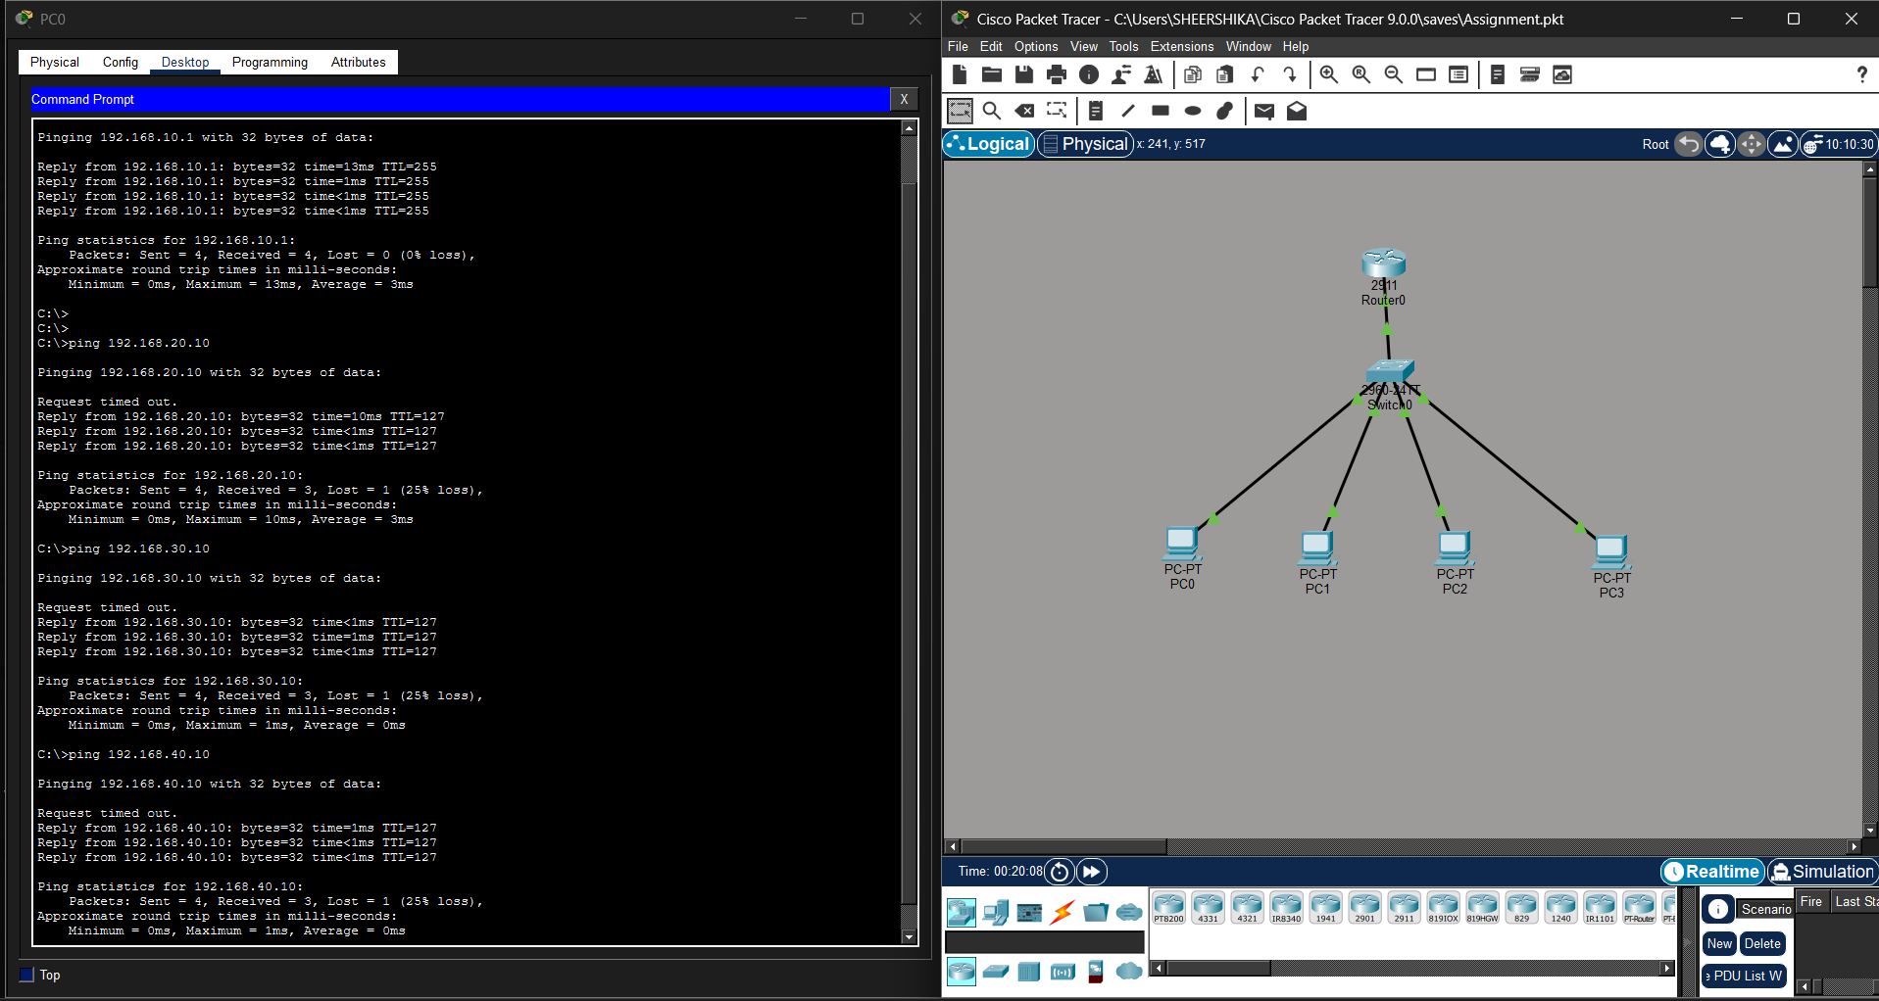
Results and Validation
The network was successfully implemented and tested in Cisco Packet Tracer. Four separate VLANs were created for Administration, Faculty, Students, and Guests. Each department was assigned a unique IP subnet and default gateway.
The router-switch connection was successfully configured as an IEEE 802.1Q trunk. Router sub-interfaces were configured to provide inter-VLAN routing. Ping tests confirmed successful communication between devices in different VLANs, demonstrating that the Router-on-a-Stick configuration was functioning correctly.
Analysis, Comparison, Trade-offs and Justification of the Final Solution
Two common approaches for inter-VLAN routing are Router-on-a-Stick and Switch Virtual Interface (SVI) routing.
Router-on-a-Stick — Selected Solution
This method uses one physical router interface with multiple sub-interfaces. Each sub-interface represents a separate VLAN.
Advantages:
- Simple configuration
- Requires fewer devices
- Suitable for small networks
- Cost-effective
SVI — Alternative Solution
SVI routing uses a Layer 3 switch to perform routing between VLANs.
Advantages:
- Better performance
- More scalable
- Suitable for larger enterprise networks
Justification
Router-on-a-Stick was selected because the proposed network is small and contains only four VLANs. It is easier to configure in Cisco Packet Tracer and successfully meets the requirements of the assignment.
Broader Considerations / SDG Relevance
SDG 4 – Quality Education
The assignment improves practical networking knowledge and develops hands-on technical skills using network simulation tools.
SDG 9 – Industry, Innovation and Infrastructure
The design demonstrates how structured and scalable network infrastructure can be created using VLAN technology.
SDG 11 – Sustainable Cities and Communities
VLAN-based networks are relevant to modern connected environments such as smart campuses, buildings, and digital infrastructure.
Conclusion, Limitations and Possible Improvements
Conclusion
The VLAN-based enterprise LAN was successfully designed and implemented using Cisco Packet Tracer. Four separate VLANs were created for Administration, Faculty, Students, and Guests. Inter-VLAN communication was successfully achieved using Router-on-a-Stick, and the configuration was verified through ping tests.
Limitations
The current implementation is designed for a small network and does not include advanced security mechanisms or redundancy.
Possible Improvements
The network can be improved by:
- Implementing Access Control Lists (ACLs)
- Restricting Guest access to internal VLANs
- Using a Layer 3 switch with SVIs
- Adding more devices and departments
- Implementing DHCP for automatic IP assignment
- Adding redundancy for improved reliability
Individual Contribution of Group Members
The complete assignment, including network design, VLAN configuration, IP addressing, inter-VLAN routing, testing, validation, and documentation, was completed individually.

References
- Cisco Networking Academy, VLANs and Inter-VLAN Routing.
- Cisco Packet Tracer – Network simulation and configuration tool.
- IEEE 802.1Q Standard for VLAN tagging and trunk communication.
- CSA0702 – Computer Networks course materials and lecture notes.

One-Page Individual Reflection
This assignment provided practical experience in designing and implementing a VLAN-based enterprise network using Cisco Packet Tracer. The main design decision was to separate the Administration, Faculty, Students, and Guests departments into individual VLANs to achieve logical network segmentation. Router-on-a-Stick was selected for inter-VLAN routing because it was suitable for the small network topology and allowed multiple VLANs to communicate through a single router interface.
During the implementation, challenges were faced while configuring the connection between the router and switch. Initially, the trunk configuration was applied to the wrong switch interface, which resulted in connectivity failure. This issue was identified using network verification commands and corrected by configuring the actual router-connected switch port as a trunk. This troubleshooting process improved understanding of the importance of correctly identifying physical interfaces and verifying network configurations.
Through this assignment, I gained practical knowledge of VLAN creation, switch port assignment, trunk configuration, IEEE 802.1Q tagging, IP addressing, router sub-interfaces, and inter-VLAN routing. I also learned how to use commands such as show vlan brief, show interfaces trunk, and show ip interface brief to verify and troubleshoot the network.
The assignment is connected to SDG 4 – Quality Education because it develops practical technical and digital skills. It also relates to SDG 9 – Industry, Innovation and Infrastructure by demonstrating the design of structured and scalable communication infrastructure.
Overall, the assignment helped me achieve the relevant course outcomes by applying networking concepts in a practical environment. It strengthened my ability to configure, test, troubleshoot, and evaluate a VLAN-based enterprise network.

